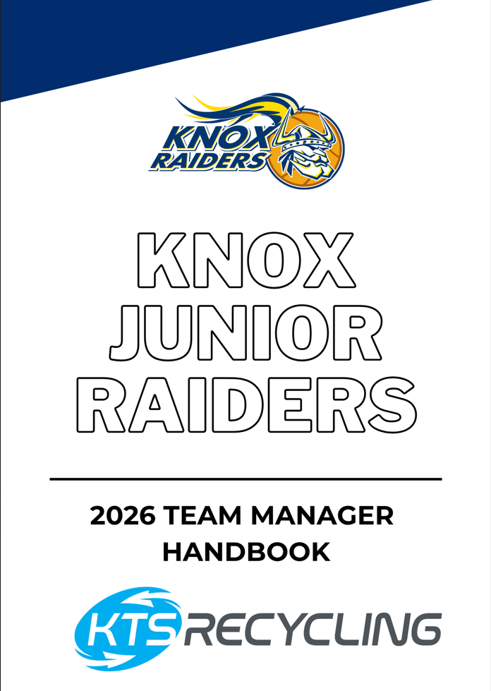

KNOX JUNIOR RAIDERS CONTACTS

Director of Knox Junior Raiders: David Ingham - 0404 531 304
(email: david.ingham@knoxbasketball.com.au)

Finance Manager: Melanie Hedley - 0433 071 078
(email: accounts@knoxbasketball.com.au)

State Basketball Centre: 291 George Street, Wantirna South Vic 3152
03 9847 2300

VJBL Friday Night emergency 0430 541 847
phone number:

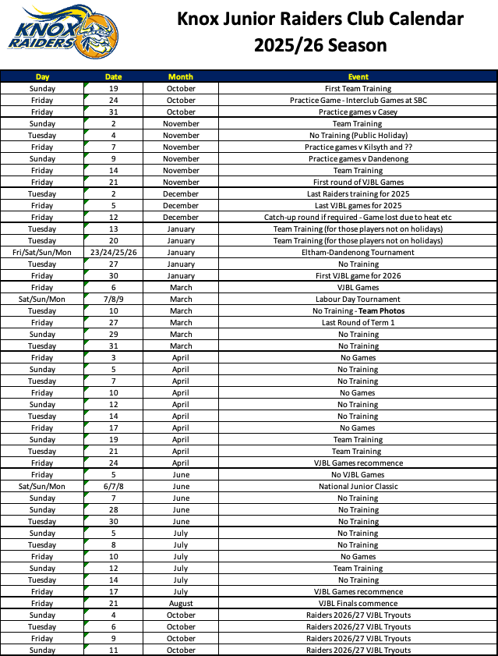
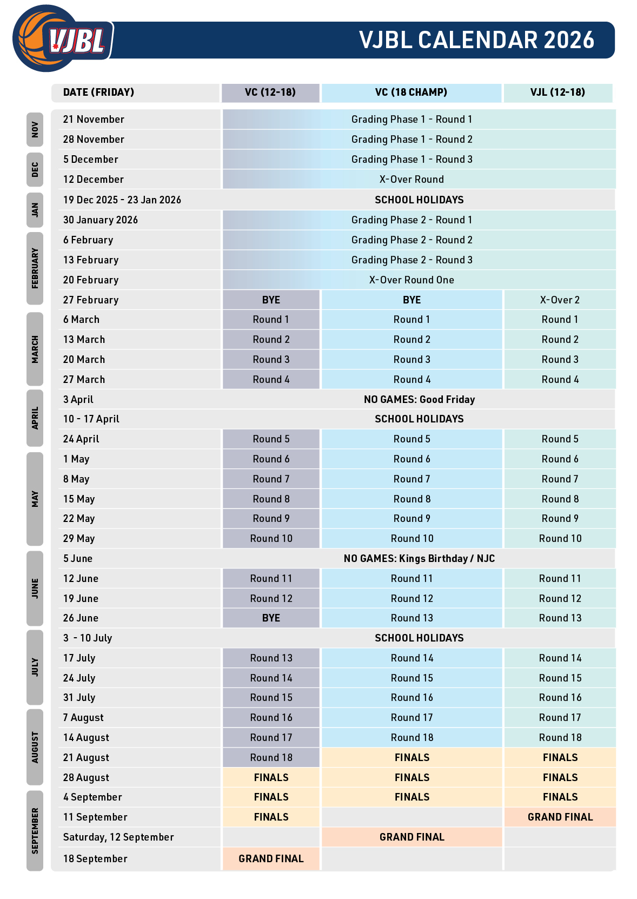

TEAM MANAGER DUTIES

Thank you very much for taking on the responsibility of Team Manager for the 2025/26 season.

The Team Manager (TM) role is an integral part of the Knox Junior Raiders administration. You will play an important role in ensuring the smooth and successful running of the playing and coaching operations for the upcoming season.

A TM’s job is to ensure that the coach is free to coach and does not have to worry about:

- Who is scoring
- Paying for the team sheet
- Uniform clashes (home team needs to change)
- Player availability, etc.

It is important to support the coach at all times. If any problems arise with the playing group or your parents, the Director of Knox Junior Raiders, David Ingham, must be informed immediately.

It is important that you SIGN IN at the door of the venue you are attending for your game and ensure coaches have signed in, otherwise the fine issued by the VJBL will be passed onto your team for payment.

All teams are expected to appoint a Team Manager and even a backup TM, at the beginning of the season that will step into the role in your absence (either from illness or unavailability). This person must be approved by Mel Hedley prior to being approached and then must complete ALL the necessary paperwork including Working with Children (WWC) check.

The backup TM will assist you in your absence but must be included in the scoring roster and other team duties throughout the season.

NO ONE ELSE has permission to sit on the bench on game day! You must NOT just replace yourself, all officials MUST be approved and processed by Mel Hedley as per child safety standard requirements.

In the instance that the proxy TM is also unavailable, please make these arrangements well in advance, not on the day of the game! Any requests made on game day will not be actioned and will result in the team having no support staff on the bench that night!

ORGANISING THE TEAM LIST

Once the team has been confirmed and you have been appointed as TM you will be provided with a full team list. Please confirm the details are accurate and fill in any missing information, including the singlet number the players have been allocated.
Any changes need to be sent through to the Director of Junior Raiders, David Ingham (david.ingham@knoxbasketball.com.au).

As part of the start of the year duties, all TM’s will receive a team bag, basketball and first aid kit for use throughout the year. If you require any additional medical supplies, such as bandaids or ice packs, these can be obtained from the Uniform Shop on a Tuesday night.

Playing singlets are purchased by athletes through the online Knox Basketball store, however in the case of new players, Knox Junior Raiders will provide a loan singlet as required. Should there be any issues with uniform, please contact Mel Hedley (accounts@knoxbasketball.com.au).

A set of navy alternate singlets are available should you have a colour clash or if not all your players currently have a reversible singlet, please email with plenty of notice to arrange access to singlets.

COMMUNICATION


Our club uses the ‘STACK TEAM APP’ app as the main communication platform.
It is important that all parents, and athletes have downloaded and registered to use the app.

The link for the app is: https://knoxjuniorraiders.teamapp.com/
We have been working really hard to ensure that access to Team App has been completed by every member and that every player and their guardians are allocated to their team.

You should always be the first point of contact for your team. You are there to assist in any way possible in order to free the Coach up to be able to do what they do best – coaching.

David Ingham is available should you require assistance or wish to raise a concern.
The KJR program has ‘private’ social media accounts that we use to share important information, photos and other fun content amongst our members.

Facebook: https://m.facebook.com/groups/508586439516738er

Instagram: https://www.instagram.com/knoxjuniorraiders/
Please ensure you encourage your team member and family members to join these groups.
Kindly let them know that they MUST answer all membership questions to be granted approval to join the facebook page, and they MUST send a PM with their/their child’s name & team, to be granted approval to join the instagram page.

.

PLAYER INJURIES/MEDICAL CERTIFICATES

Players who are ill or unable to play must notify the TEAM MANAGER as soon as they are aware that they are unable to participate in training or games.

It is imperative that medical certificates are lodged within the first 10 days of injury or illness requiring more than TWO week’s recovery.

Certificates MUST BE uploaded by parents using the cognito form link below:

https://www.cognitoforms.com/KnoxBasketball1/KJRMedicalCertificateSubmission

This certificate can be used to gain credit for missed games and will ensure that the athlete does not miss out on qualifying for finals.

ADDITIONAL INFORMATION:

- Please note that if a player wishes to train or play earlier than stated on the original medical certificate then another certificate is required from a medical practitioner stating that the player is able to return to participation earlier than planned. This certificate should be uploaded via the cognito link provided above.
- Medical Certificates WITHOUT an end date will require a medical certificate clearance. Again, this is to be uploaded via the cognito link provided above.
- Requests for clearance MUST be submitted NO LATER than the Thursday prior to the game they wish to play. Any submissions made on game day WILL NOT be actioned for that night.

ATTENDANCE AT GAMES AND TRAINING:

Players who are recovering from an injury or non-infectious illness are expected to attend all games in Raiders attire (not their playing uniform) and sit on the bench with the team, and in addition, attend all training sessions, unless there is another arrangement in place. If the illness is infectious the player MUST stay away from trainings and games – for obvious reasons.

TEAM BASED ACTIVITIES

The Raiders program provides our children with an opportunity to make lifelong friendships. An integral part of any Raiders season is planned activities away from the courts and outside the basketball stadium.

In discussion with your coach, you will need to organize a couple of activities for the team throughout the season. It could be a session at the local swimming pool, bowling or tree climbing or a meal with family members after a game or training.

The cost of these events should be paid from by the families at the time of the event. You should aim to have AT LEAST 2 extra-curricular activities per season.

FEES & FINANCE

Each team must be self-supporting with you being responsible for collecting and paying for the weekly team sheet costs and tournament fees via Teampay.

We recommend that you set up the payment draw down for Tuesday night at training, prior to the Friday night game. These payments happen in real-time, therefore you will know immediately if a transaction has declined giving you the opportunity to discuss with any families that have an issue.

If the payment hasn’t been released by Thursday, you must contact Mel Hedley (accounts@knoxbasketball.com.au) immediately for assistance and further advice.

Payments will be taken for ALL players each game regardless of their availability. Those sick, on holidays or injured are still required to play each week.

Depending on the team sheet cost, the amount is divided by the players in your team. We make an assumption that you have 10 players, so therefore $125 team sheet cost means a $12.50 per week transaction plus the transaction fee. We will be using Teampay to collect tournament fees and sock collection fundraising money.

Teampay is centrally monitored and reviewed by Knox Basketball office. The financial burden should not be worn by you. If you need any assistance, please contact Mel Hedley (accounts@knoxbasketball.com.au).

In any case DO NOT:

- Accept cash/bank deposit from families to ‘cover’ the Teampay transaction. All transactions should come from each families account.
- Pay from your own funds for families that are unable to pay on any given week.
- Teams/Team Managers are NOT to have a team kitty fund.
- Team Bonding activities are to be paid on the day of the bonding session by each player/parent.
- If a deposit for a team bonding activity has to be paid, the TM can deduct this from the final amount due for said team bonding activity (or coach’s gift).
- Coach’s gifts will require some cash collection, but please note that the amount is capped at $100 for a head coach gift and $50 for an assistant coach gift. The cost is to be split evenly between all players. For example, based on a team with 10 players, the expense to each player would be $15.00 (meaning $10.00 is allocated for the head coach gift and $5.00 for the assistant coach gift).

TEAM SHEET COSTS

DOOR ENTRY COSTS:

Door entry costs have been incorporated into the team sheet cost, and therefore no door entry will be charged at any venue for the GRADING and CHAMPIONSHIP SEASON.

TEAM SHEET COSTS

- $125.00 per game (60 Minute Timeslot – 4 x 10-minute quarters)
- $160.00 per game (80 Minute Timeslot – 4 x 7 or 4 x 8-minute quarters)

If your team qualifies for finals, please be aware that the team sheet cost may increase for finals games.

SCORESHEET

An important task for you to manage each week is to ensure that the score sheet is always completed correctly.

It is important that you check ALL eligible players (playing that game) are on the scoresheet and that their name and playing number is correct.

In the case that this is incorrect, change it on the scoresheet and then contact David Ingham (david.ingham@knoxbasketball.com.au) who will adjust the back end of Play HQ with the correct details. You must also check that the coaching staff names are listed and correct.

SCORING

Scoring is a fundamental component of our game. We are obligated to supply a competent bench official for each game. As Team Manager you will need to draw up a roster that shares the scoring between the families and ensure that each family is provided with a copy.

Creating the roster can get complicated when a parent is the coach, assistant coach or you have more than one team manager, we suggest you use your common sense when navigating through this.

We offer the following advice:

If you have 2x Team Managers – 1 is designated game day TM, the other must be included on the scoring roster. If you have a parent Head Coach – their family should not be placed on the scoring roster, unless they offer to be included.

If you have a parent Assistant Coach – discuss with the Assistant Coach (and wife/husband/partner), if the other parent intends to be present at games to watch their child, they may offer to be included on the roster.

It is a good idea to buddy up new or unsure parents with competent scorers within your team for the first few times to provide them with additional support.

Scoring etiquette is that the home team does the scoreboard/clock and the away team does the computer.

NOTE: At neutral venues the first listed team is considered the home team.

Make sure that you have a copy of the timing rules for your grade and ensure that each scorer understands them (timing rules are included in this TM information guide).

We recommend that you keep a record of your team’s results during the season.

SCORERS CODE OF CONDUCT

Whilst scoring it is important to remember the following things:

- No mobile phones are to be used while you are scoring.

- Scorers MUST NOT CHEER, BARRACK or YELL OUT from the score bench and must not offer any comments to Referees who are officiating or show reaction to the game situation.

- Scorers must conduct themselves in a professional manner and avoid involvement with the behaviour of others. All communications with other participants shall be in a courteous manner.

DISPUTES & COMPLAINTS PROCESS

KJR has a Grievances & Complaints Policy and Process. This document is located on the Knox Basketball website.

In the first instance, you can speak with your Age Group Co-Ordinator or you can speak to Director of Junior Raiders, David Ingham (david.ingham@knoxbasketball.com.au) if you wish to raise any issues or concerns that you or your child(ren) may be experiencing. He will provide you with general advice or advise you of the process to lodge a formal complaint.

If you are aware of any issues within your team, please advise your players and their parents to access this policy and procedure and follow the steps to lodge a complaint.

NO ZONE POLICY – U12 & U14s

The entire U12 & U14 VJBL competition MUST COMPLY with the No Zone policy.

No team is able to play a zone in any VJBL game. It is important to note that zones may be played in tournaments – however not by Raiders teams (internal rule).

All U12 & U14 coaches MUST complete the NO ZONE CLINIC to be able to coach. This is a one-off requirement, and once completed, they do not need to do it again unless advised to do so.

Even with this policy and clinic in place, there may be times your team plays against a zone (in a VJBL game), it is important for you to remember the following:

- Referees are unable to take action in relation to the zone on game night.
- A NO ZONE form must be completed and submitted to david.ingham@knoxbasketball.com.au and cc’ed to junior.raiders@knoxbasketball.com.au by the Sunday morning after your game.

You must provide video evidence of a least 1 MINUTE long with your submission.

David Ingham will lodge your complaint to the league no later than Monday morning.

SNACK PACKS FOR COUNTRY TEAMS

It is a Knox tradition that when playing a team from the ‘country’ at our home court, we supply their team members with a snack pack to take home with them in the car/bus.

A country team would be considered one from regional locations such as Ballarat, Wangaratta, Bendigo, etc.

The cost of these packs should be funded by the team. You can simply put together a pack with, for example: juice pack or flavoured milk, a banana or apple, a small bag of pretzels or popcorn and/or a small bag of lollies.

If you require further clarification, please don’t hesitate to contact Mel Hedley.

FIRST AID

Each team is supplied with a First Aid Kit.

Please ensure that the kit is kept full and is always taken to games.

Replenishment of supplies can be done by contacting Mel Hedley (accounts@knoxbasketball.com.au). It is also a good idea to check with the parents on your team to determine if anyone has a first aid certificate in case of injury.

NOTE: Blood on a team top or shorts can be easily washed/rinsed out at the venue and worn wet (they will dry quickly and easily).

TEAM MANAGER DRESS CODE

As the Team Manager, it is important you remember that you are also representing Knox Raiders. All TMs are expected to wear Knox Raiders apparel whenever they are acting in the role of Team Manager. This will ensure you are identified as part of the team.

A polo & a yellow t-shirt will be provided to all Team Managers that sit on the bench for Friday night games. A yellow t-shirt only will be provided to all secondary/proxy Team Managers.

SITTING ON THE BENCH

The Team Manager MUST sit on the bench during games.

This is helpful to the coach for many reasons, including:

- First Aid assistance
- Refilling drink bottles during the game
- Keeping the players on the bench focused
- Tying shoelaces (for the younger age groups)
- Helping remove blood from uniform items
- Keeping a positive/upbeat vibe with players

If a coach does not have an assistant coach, they may ask you to assist in other areas as well, each coach is different and this needs to be clarified with them before the first game, so everyone knows what to expect on game day.

UNIFORM REQUIREMENTS

A) At Training: All athletes are required to wear the official Knox Junior Raiders training uniform. This consists of reversible singlet (navy & yellow), navy training shorts and Knox Basketball over garments, only.

OTHER APPAREL (such as NITP, State, other association, or Tournament clothing) is NOT to be worn to training or game night.

Please note that the playing uniform (singlet and/or shorts) are NOT to be worn to training or at any other times.

B) At Games: Players may only attend games in KNOX APPAREL. Players are required to wear the Knox warm-up top for their warmup and approved KJR apparel as a warm layer in the colder months.

Players are required to purchase their own Raiders playing uniform, socks and footwear. All Knox apparel can be purchased online through the Knox Basketball website or in person at the Uniform Shop at SBC.

All players must have the required full uniform (training and playing) by the commencement of the representative (grading) season (where possible).

It is important to understand that players wearing non-approved apparel will be subject to disciplinary action and review.
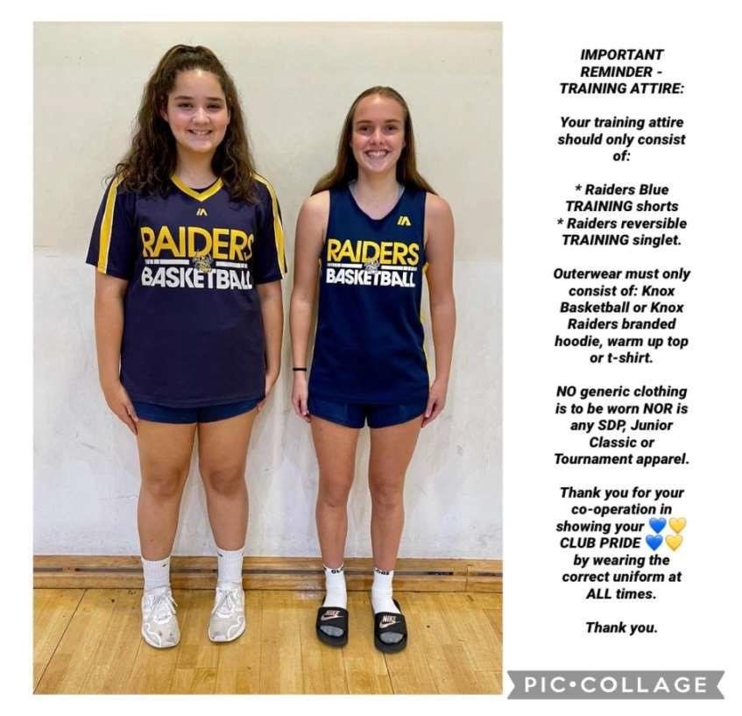
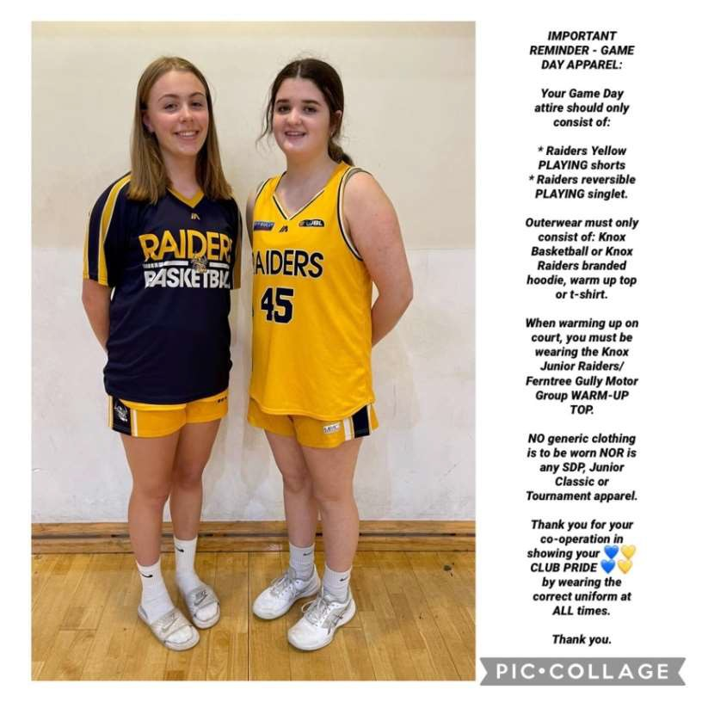

SOCIAL MEDIA

Social media is a large part of today’s way of life. Unfortunately, this can sometimes be used in a negative way.
Whilst we appreciate and acknowledge our players, parents and members right to contribute content on social networking sites, we also know that inappropriate behaviour on such sites has the potential to tarnish the reputation of our association and players.

With this in mind, Knox Basketball is in full compliance with the VJBL rules and media regulations concerning social media.

“All members must refrain from posting, sending, forwarding or using in any way, any inappropriate material that may cause insult, offence, intimidation or humiliation to any of our players, parents, members or associates within the basketball community. This includes the encouragement of inappropriate material such as liking, re tweeting, re posting and general promotion of unacceptable behaviour, photos or comments.

Posting on all blogs or forums is also included within this policy.”

All members of Knox Basketball are expected to comply with this policy at all times. Any breach of this policy will be treated as a serious matter and will result in disciplinary action which could result in the suspension or termination of membership.

VENUES

Venue listings are located on the VJBL website and is kept up to date regularly. This information can be found at:

https://www.basketballvictoria.com.au/resources/competition-resources/vjbl.

If you are unsure about a venue or its address, please check the website to confirm the information you need.

Please encourage all the parents on the team to regularly check the website and become familiar with locating a stadium and its address.

COMPRESSION GEAR/UNDER GARMENTS

Any compression item must be black, white or same dominant colour of playing singlet. Association/ sponsor logo or branding is allowed if size is no larger than 1cm x 2cm.

The colour choice will be decided by the player’s association to ensure that teams have uniformity if more than one player in a team is wearing compression gear.

This means that if one player is wearing black compression gear, any other player in the team must also wear black in any compression gear worn.

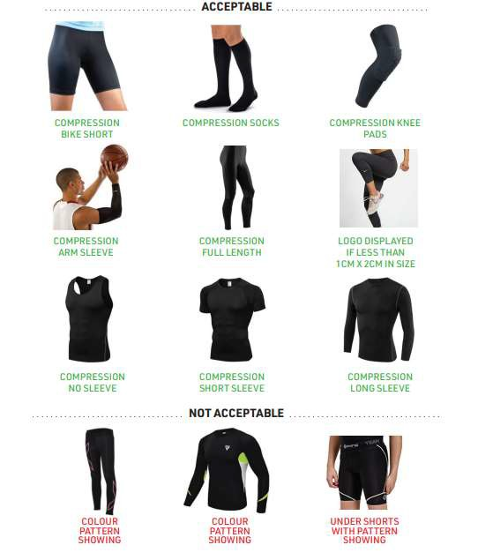

COLOUR CONTRAST RULES

The rule reads: “The home team (or first named team when both teams are fixtured away) will change from its primary colour to ensure an appropriate colour contrast clearly exists.”

A potential change in singlet will be required if your team is playing any of the teams listed in the YELLOW/GOLD category on the colour contrast listing (included in this TM information guide). Currently these teams are Knox, Chelsea, Kyneton, Sherbrooke & Wyndham.

It is important however to keep up to date with the online uniform contrast list accessed via https://www.basketballvictoria.com.au/resources/competition-resources/vjbl.

Please ensure that this rule is strictly adhered to as fines will be imposed by the VJBL if not followed. If you need any further assistance please don’t hesitate to contact David Ingham (david.ingham@knoxbasketball.com.au).
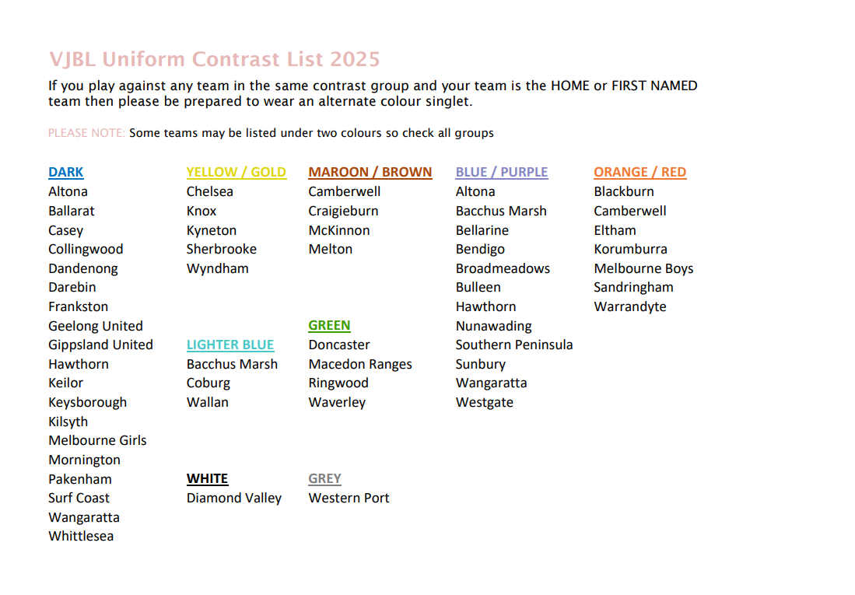
NOTE: If you play against any team in the same contrast group and your team is the home or first named team on the fixture then your team MUST wear our alternate colour (BLUE).

TOURNAMENTS

The KJR program will participate in the Eltham-Dandenong Tournament, South-East Junior Basketball Tournament and National Junior Classic this season.

All players are expected to be available for these commitments.

The cost of tournament participation is to be funded by the team and will be paid via Teampay.

David Ingham will complete the team registrations and organise for payment of entry fees. These fees will then be invoiced to you for payment.

Eltham-Dandenong Tournament (EDT):

This tournament is run over the Australia Day weekend.

Team Managers – there is nothing for you to do in terms of registration, this will be managed by David Ingham. We will advise once there is action for you to take.

South Eastern Junior Basketball Tournament (SEJBT):

This tournament is run over the Labour Day weekend.

Team Managers – there is nothing for you to do in terms of registration, this will be managed by David Ingham. We will advise once there is action for you to take.

National Junior Classic Tournament:

This tournament is an invitational event only for qualifying VC teams.

Regardless of the tournament, it is your responsibility as TM to check the website for your team’s fixtures for the relevant tournaments and communication that information to the team.

You will need to provide scores & spotters for all tournament games – we recommend you continue your regular season roster over tournaments.

OTHER IMPORTANT INFORMATION

Team Managers should reference the Rules of Operation document located on the VJBL website for any rule clarification: https://www.basketballvictoria.com.au/resources/competition-resources/vjbl.

In an emergency, the Friday night mobile is 0430 541 847. Help is available from 5pm on Friday.

WEBSITE RESOURCES

Knox Basketball:
https://www.knoxbasketball.com.au

Basketball Victoria:
https://www.basketballvictoria.com.au

Items of use on the Basketball Victoria/VJBL website:
- Updated fixtures venue listings
- Uniform contrast listing season calendar
- VJBL parent handbook
- Timing rules and all other information

IMPORTANT: Coaches, Team Managers, Parents or Players must NEVER contact the VJBL office. All communication must be done through the Director of Coaching (David Ingham). Fines are issued for infractions – these will be forwarded on to the team for payment.

SHOT CLOCK GUIDELINES

VJBL games use a 24 second reset shot clock.

The shot clock is about team control of the ball. The shot clock runs for a team until the opponents take control of the ball and it resets and runs for them.

The shot clock operator should always be watching the ball as control of the ball determines their actions.

It is good practice to pause the clock and look to see how many seconds are remaining before resetting and running. That way, if the referee decides they want to reset the shot clock to its previous setting, you can advise them of what the correct position was.

The shot clock will be reset:

- When there is a change in team control (e.g. a turnover of any sort)
- All fouls
- When the ball hits the ring after a shot

In other situations when directed by the referee (e.g. deliberate kick of the ball, play is interrupted by something outside the control of the offensive team). The referee will request the reset by moving their index finger in a circle above their head.

The shot clock is paused on every whistle and is reset if there is a change in team control. The shot clock is not reset if the same team retains possession of the ball.

This also applies in “possession arrow” situations.

A change in control in general play can be subjective but will usually occur when the opponent gets clear control of the ball with one or both hands or has commenced a controlled dribble with the ball. Simply deflecting, touching or hitting the ball is not enough.

The defensive team has to take control of the ball before team control changes. If the ball is loose on the floor, the shot clock continues to run for the offensive team until change of control.

The shot clock restarts when the ball touches a player on the court similar to the game clock.

In any out-of-control and possession arrow situations, you may want to wait to reset until it is clear when team the referee is going to give possession to as, if the same team retains possession, no reset is required.

After the ball hits the ring, reset to 24 and leave paused until it is clear which team now has control of the ball.

If the shot clock expires and the siren sounds, leave the clock set to ‘0’ until the referee calls a violation (taps hand to shoulder) or has clearly called play on. For example, if the clock expires and the defensive team immediately get clean possession referees will call play on rather than whistling for a violation.

If there is a ‘reset’ situation and there is less than 24 seconds remaining on the game clock, reset the shot clock to 24 and leave it paused so players know to work to the game clock.

Make your best judgment and go with it. Referees will override your call at times but many “changes in control” are subjective so don’t stress if they have a different view. It is rare that a mistaken or slow reset will change the result of the game as usually there is turnover or fouled or something soon after that anyway.

UNDER 14s:

Where specified the shot clock will be in operation as per the FIBA rules, except the shot clock won’t rest to 14 seconds, with the exception of the Under 14s age group.

Shot clock rules for Under 14s shall be as follows: (this coincides with the U14 Club Championships). The 24 second device will not be started until the ball enters the team’s front court.

The ball enters a team’s front court when:

- It touches the front court
- It touches a player or an official who has part of his/her body in contact with the front
court.
- During a dribble from back court to front court, both feet of the dribbler and the ball
are in contact with the front court (this applies to the player only as long as they are
dribbling).

